Truncated Platonic Solids

Definition
# Source: AI Source: Provided by: [Data Path: Persons Table -> ID Column: 1, Name_En Column: Motasem Essam] -> From: [ChatGPT] on [7/25/2026]
A Truncated Platonic Solid is a three-dimensional polyhedron formed by cutting off the vertices of an original Platonic solid using planes.
The truncation process creates new polygonal faces while modifying the original faces, edges, and vertices.
There are five types of Platonic solids, and each can produce a corresponding truncated Platonic solid through uniform vertex truncation.

Types of Truncated Platonic Solids

Truncated Tetrahedron
# Source: AI Source: Provided by: [Data Path: Persons Table -> ID Column: 1, Name_En Column: Motasem Essam] -> From: [ChatGPT] on [7/25/2026]
- Original Solid: Tetrahedron
- Original Vertices: 4
- New Faces: 4 triangles and 4 hexagons.
- Total Faces: 8
- Total Edges: 18
- Total Vertices: 12
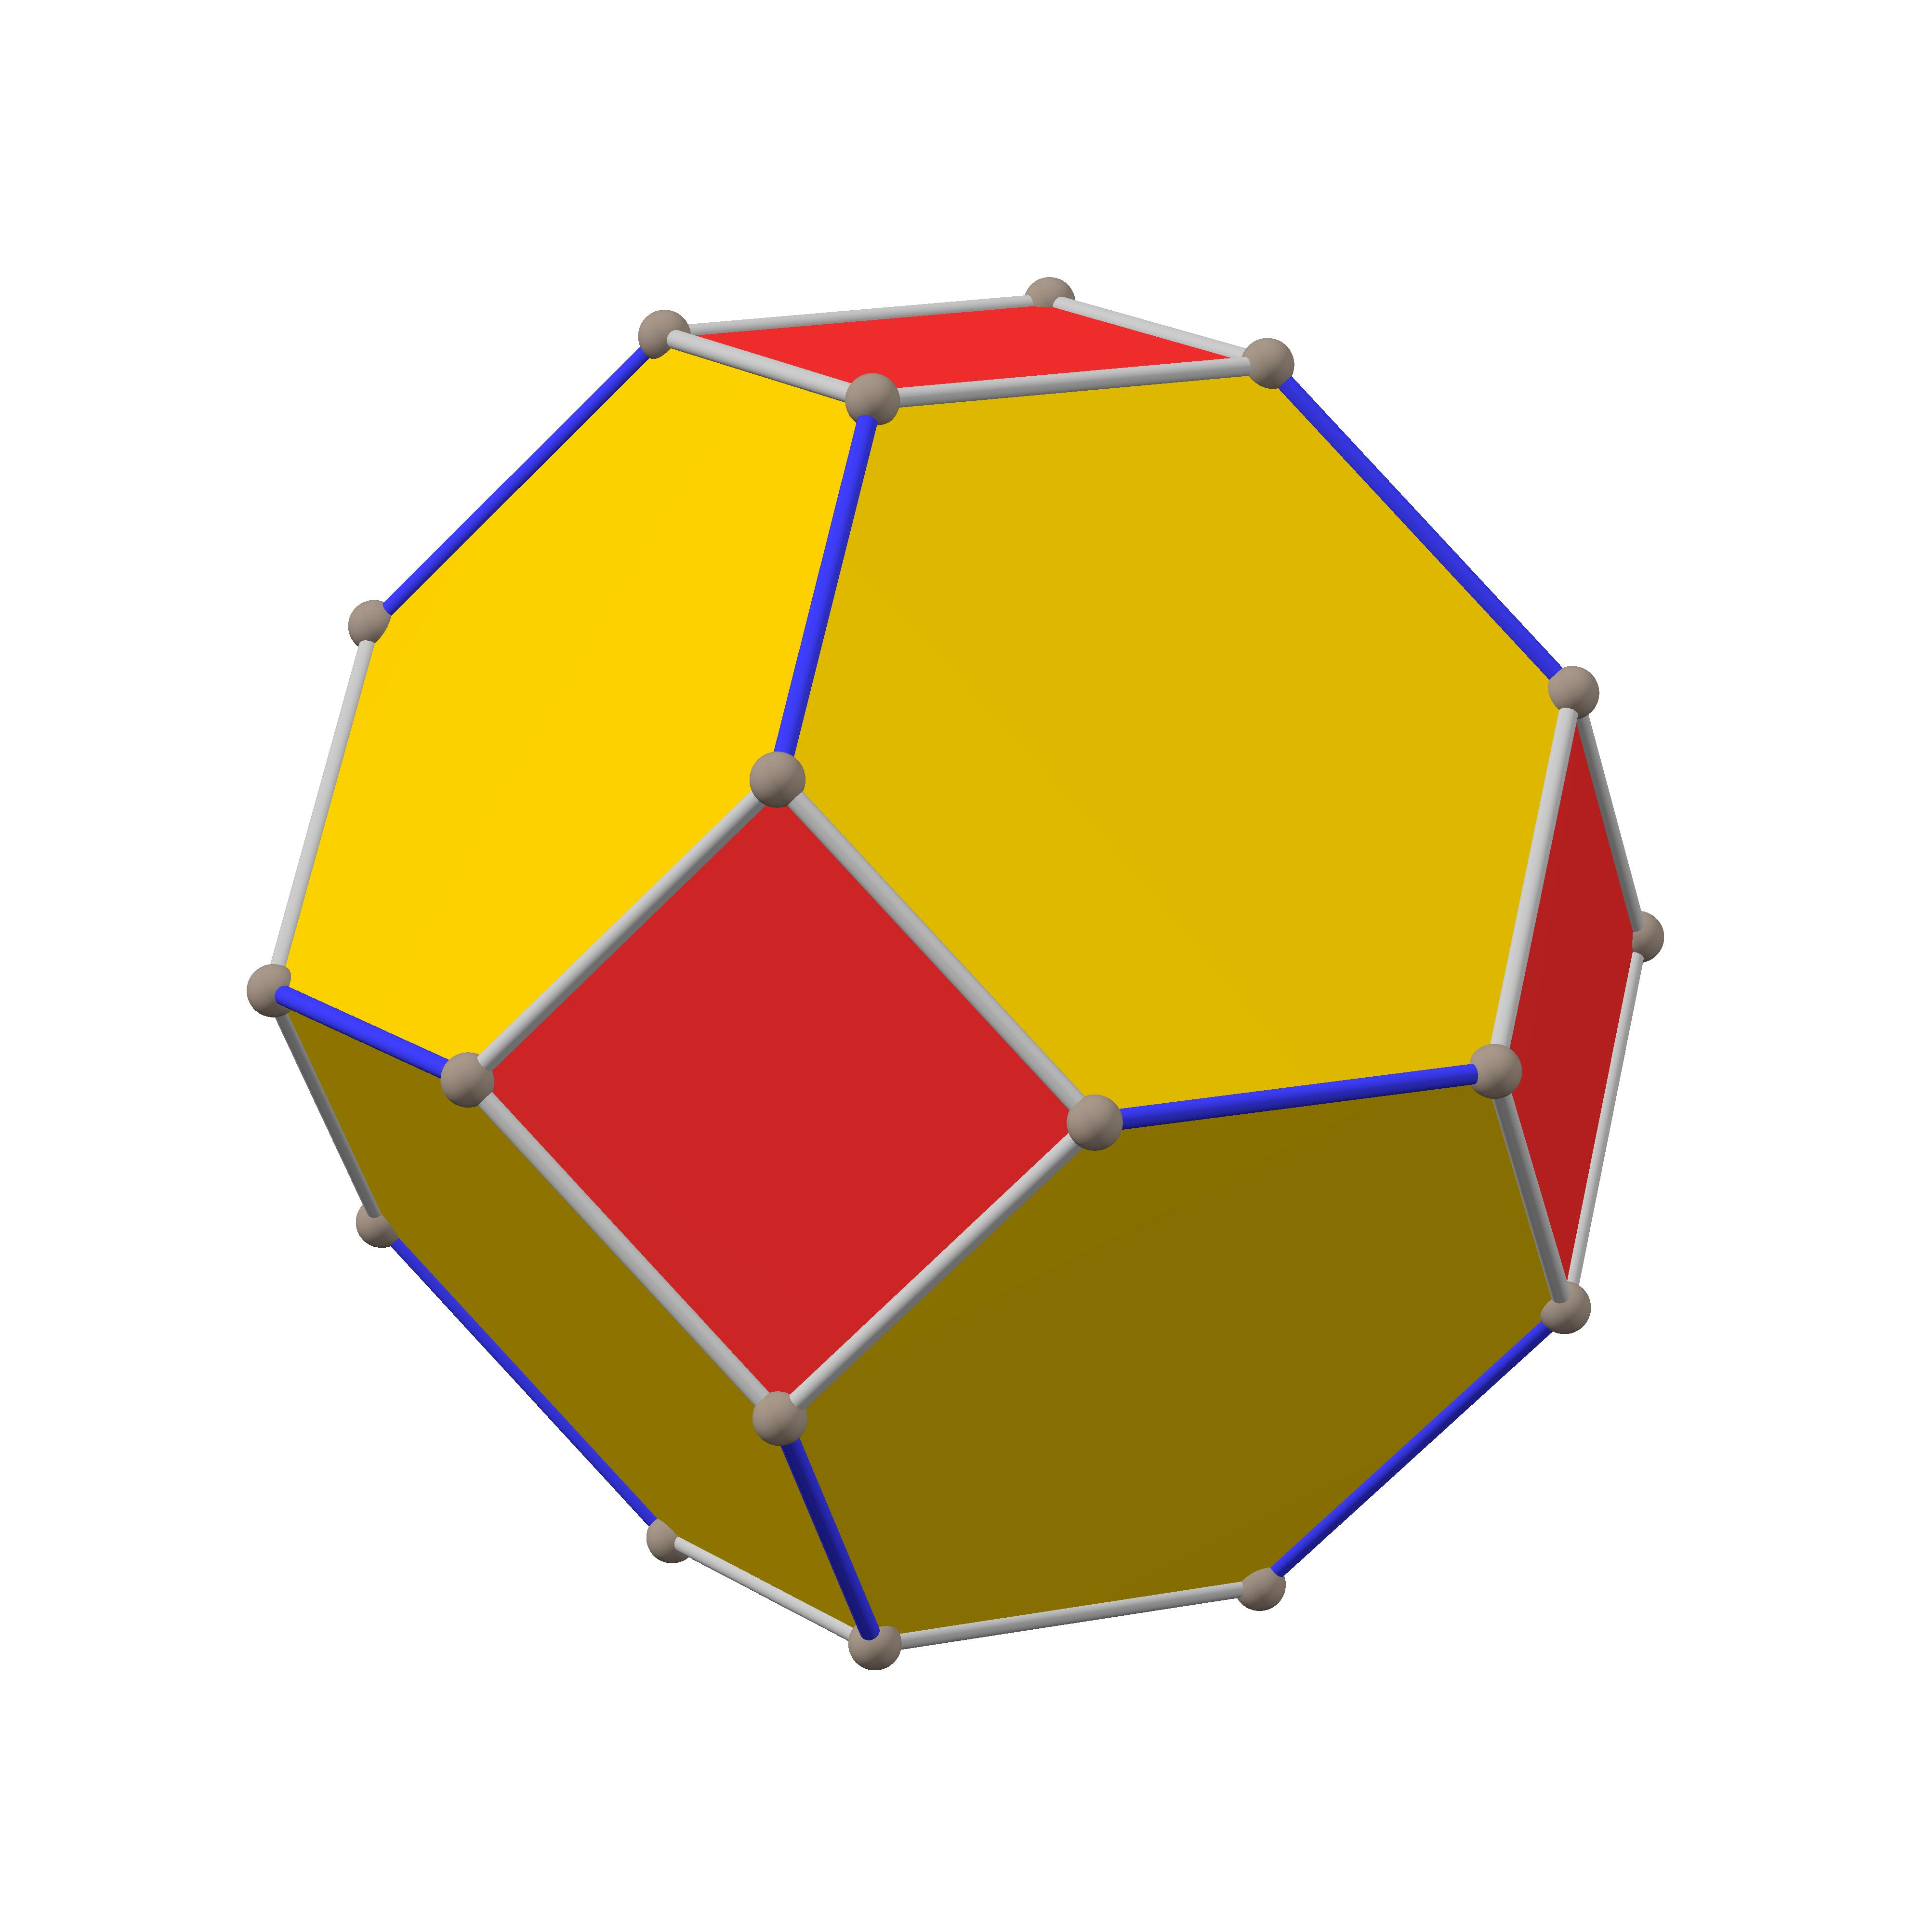

Truncated Cube
# Source: AI Source: Provided by: [Data Path: Persons Table -> ID Column: 1, Name_En Column: Motasem Essam] -> From: [ChatGPT] on [7/25/2026]
- Original Solid: Cube
- Original Vertices: 8
- New Faces: 8 triangles and 6 octagons.
- Total Faces: 14
- Total Edges: 36
- Total Vertices: 24
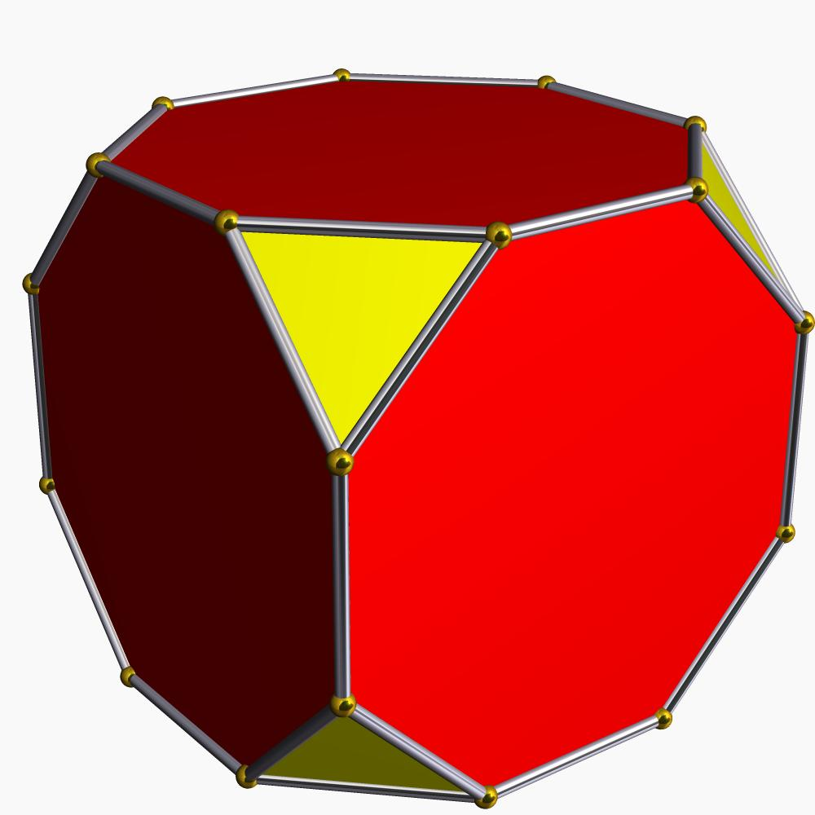

Truncated Octahedron
# Source: AI Source: Provided by: [Data Path: Persons Table -> ID Column: 1, Name_En Column: Motasem Essam] -> From: [ChatGPT] on [7/25/2026]
- Original Solid: Octahedron
- Original Vertices: 6
- New Faces: 6 squares and 8 hexagons.
- Total Faces: 14
- Total Edges: 36
- Total Vertices: 24
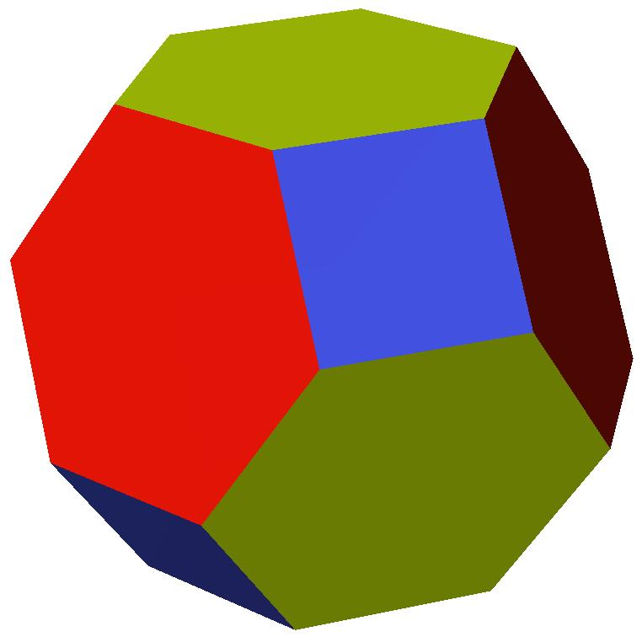

Truncated Dodecahedron
# Source: AI Source: Provided by: [Data Path: Persons Table -> ID Column: 1, Name_En Column: Motasem Essam] -> From: [ChatGPT] on [7/25/2026]
- Original Solid: Dodecahedron
- Original Vertices: 20
- New Faces: 20 triangles and 12 decagons.
- Total Faces: 32
- Total Edges: 90
- Total Vertices: 60
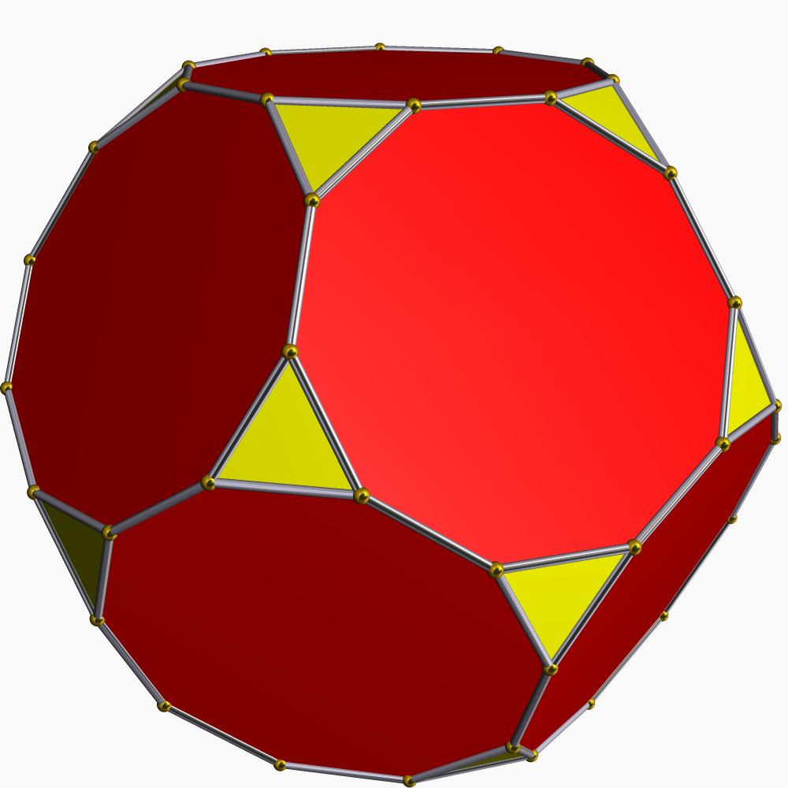

Truncated Icosahedron
# Source: AI Source: Provided by: [Data Path: Persons Table -> ID Column: 1, Name_En Column: Motasem Essam] -> From: [ChatGPT] on [7/25/2026]
- Original Solid: Icosahedron
- Original Vertices: 12
- New Faces: 12 pentagons and 20 hexagons.
- Total Faces: 32
- Total Edges: 90
- Total Vertices: 60
- 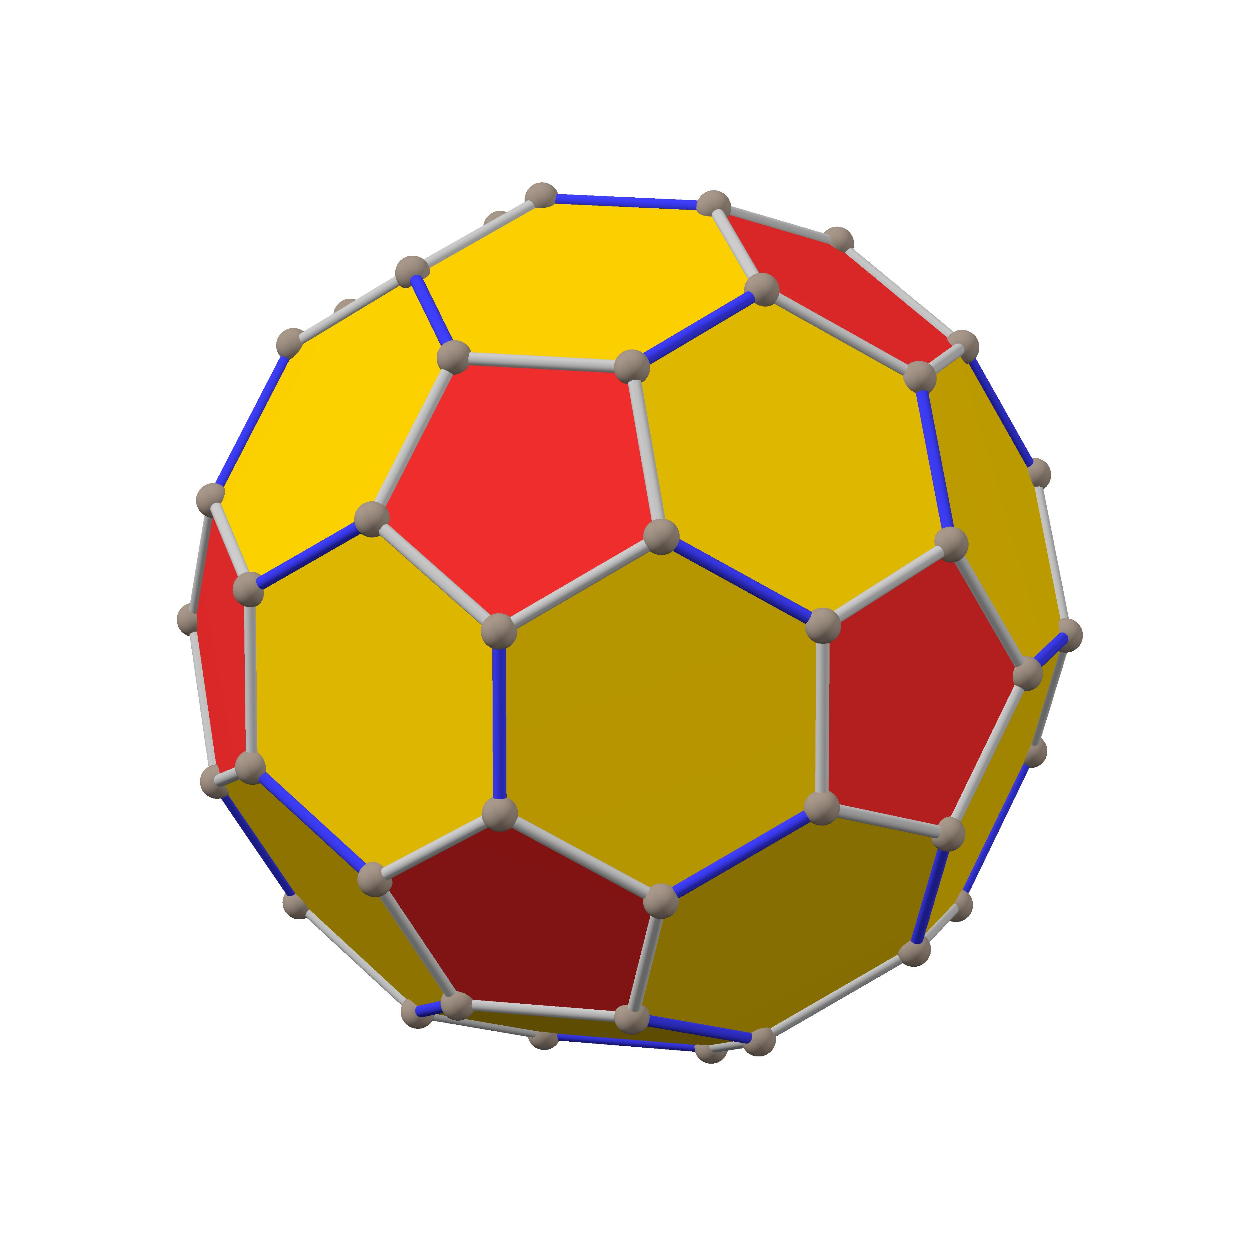

Mathematical Properties
# Source: AI Source: Provided by: [Data Path: Persons Table -> ID Column: 1, Name_En Column: Motasem Essam] -> From: [ChatGPT] on [7/25/2026]
For uniform vertex truncation of a Platonic solid:
- Each original vertex produces one new truncation face.
- Each original edge receives two new vertices.
- Each original face is modified into a smaller polygon.
The resulting solid satisfies Euler's formula:
$$V-E+F=2$$
Where:
- $V$ = Number of vertices.
- $E$ = Number of edges.
- $F$ = Number of faces.

Comparison Table
# Source: AI Source: Provided by: [Data Path: Persons Table -> ID Column: 1, Name_En Column: Motasem Essam] -> From: [ChatGPT] on [7/25/2026]
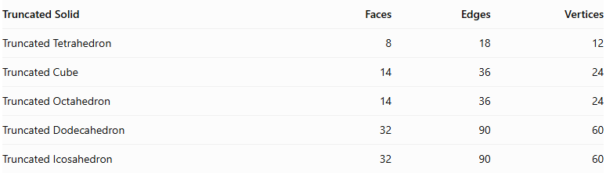
Truncated Solid | Faces | Edges | Vertices
Truncated Tetrahedron | 8 | 18 | 12
Truncated Cube | 14 | 36 | 24
Truncated Octahedron | 14 | 36 | 24
Truncated Dodecahedron | 32 | 90 | 60
Truncated Icosahedron | 32 | 90 | 60

Key Points
# Source: AI Source: Provided by: [Data Path: Persons Table -> ID Column: 1, Name_En Column: Motasem Essam] -> From: [ChatGPT] on [7/25/2026]
- Truncated Platonic solids originate from the five Platonic solids.
- They are formed through vertex truncation.
- Each removed vertex produces a new polygonal face.
- Uniform truncation preserves the symmetry of the original Platonic solid.
- All five standard uniform vertex-truncated forms are Archimedean solids.

Conclusion
# Source: AI Source: Provided by: [Data Path: Persons Table -> ID Column: 1, Name_En Column: Motasem Essam] -> From: [ChatGPT] on [7/25/2026]
Truncated Platonic Solids are polyhedra obtained by uniformly cutting off the vertices of the five Platonic solids. They form an important group of geometric solids and include well-known examples such as the truncated cube, truncated octahedron, and truncated icosahedron.

